**Shopping Cart Problem – Medium**

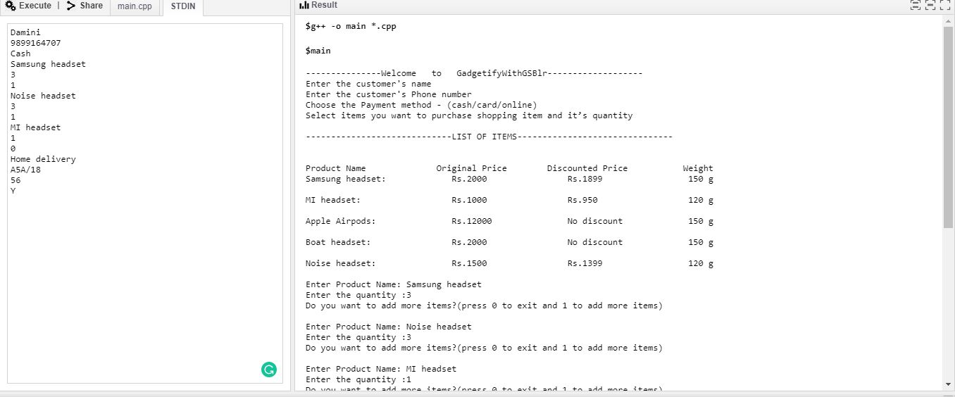

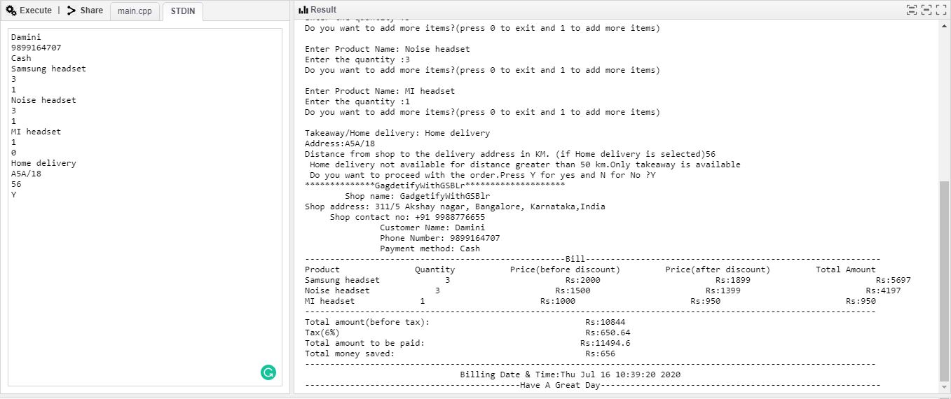

I have solved this problem using C++.I have used strings, functions, arrays, associative arrays and basic numerical operations to calculate the bill.

I have used getline to take input as it is convenient for accepting a string with multiple spaces and have done the required formatting to make it look presentable. I have also added dummy getline so that I can use getline after cin.

In my application,the user is being asked to enter product name and quantity and then a 1 if he/she wants to add another item or 0 if not. I have done all the calculations related to the bill in the function calculate which takes 4 parameters(array of selected products,array of product quantities,no. of products and distance if the customer has opted for home delivery).